REQUEST FOR PROPOSALS
RFP #23-1856

CITY OF LEBANON, OHIO

PARKS FACILITY PRELIMINARY ARCHITECTURAL DESIGN

April, 2023

CITY OF LEBANON

WARREN COUNTY, OHIO

REQUEST FOR PROPOSALS

CITY OF LEBANON PARKS FACILITY PRELIMINARY ARCHITECTURAL DESIGN

- Overview

The City of Lebanon (the "City") is currently seeking proposals from consulting firms to provide preliminary architectural design services for two proposed parks related facilities. The first is the replacement of the existing restroom / concession building in Colonial Park East. The second facility is the construction of a new outdoor performance stage in Bicentennial Park located in Downtown Lebanon. The Lebanon Parks System consists of 17 parks totaling over 600 acres, and are a key component of the outstanding quality of life experienced by our residents and businesses.

The goal of this project is to develop a preliminary facility design that can be used for budgeting purposes, and presenting to the public and City Council for potential construction funding. The plans will be detailed enough to provide exterior elevations, material specifications, and dimensions of the various components of each facility. More detailed design such as mechanical, plumbing, and electric would not be part of this initial assessment, but would be part of a final design contract should the City decide to move forward with the project(s).

Direct questions regarding this request for proposals can be sent to Scott Brunka, City Manager, via email at sbrunka@lebanonohio.gov.

- Project and Services

The City of Lebanon has a population of just over 21,000 residents and an area of just over 12 square miles. Lebanon is the County seat of Warren County, one of the fastest growing counties in Ohio. Currently, Lebanon is served by 17 public parks as shown on the attached map. The existing restroom / concession building in Colonial Park East was originally constructed in 1984, and is in need of replacement. Colonial Park East serves the youth baseball and softball programs, and also connects to the French Run Trail system. The new restroom / concession building will be sized to support the needs of the baseball / softball programs and reflect a modern design. This includes restrooms, concessions, and equipment storage areas. Photos of the existing building have been included in this document for reference.

Bicentennial Park is located in the heart of Downtown Lebanon, and is the hub for many of the Downtown Festivals held throughout the year. There is an existing gazebo in the park that would be demolished, and replaced with a permanent performance stage capable of supporting the needs of the existing and future outdoor performances in the park. These performances include concerts, plays, and other activities. The minimum size of the stage shall be 24 feet long and 16 feet deep. The design of the performance stage should compliment the historic nature of Downtown Lebanon, and a general concept rendering has been included with this document. The preliminary design shall include sizing and location information, renderings, and enough lighting / sound detail to generate an accurate construction cost estimate.

- Requested Information

To properly assess each Respondent’s qualifications for this Project, the City requests that each Respondent respond with the following information in the order that it is presented below. Responses must be limited to the experience of the branch office and/or individuals that will have direct responsibility for the execution of the Project.

  - Technical Qualifications

Respondents to the RFP shall demonstrate their ability to perform the Work by providing the technical qualifications of the Respondent, and individual team members. The Evaluation Committee will give most consideration to experience related to studies of a similar nature to this project.

The Evaluation Committee reserves the right to conduct an independent investigation of the Respondent’s technical qualifications by contacting Project references, accessing public information, or contacting independent parties. Additional information may be requested during the evaluation of technical qualifications. At a minimum, the Respondent and its subcontractors shall provide the following information to demonstrate their technical qualifications:

- Park Facility Planning / Design Experience — The Respondent shall provide its individual member and collective experience in similar facility architectural design projects. Describe in greater detail projects most similar to this Project.

- Key Project Staff — The Respondent shall provide the qualifications of all key staff assigned to the Project. This submission shall include the key staff of the contracting firm, its parent (if applicable), and partner firms. Information shall include length of time practicing in the profession, familiarity with design and construction of park facilities, and proposed project leadership. Full resumes of key personnel shall be provided.

- Project Approach – What methods are utilized to ensure that all information relevant to the decision-making process is captured and evaluated?

Along with the above information, Respondent must provide all relevant professional licenses and certificates of registration required to fully perform the Project.

  - Relevant Project Experience

In addition to providing technical qualifications and experience, the Respondent shall provide a list of up to five directly relevant projects completed within the past ten years that the Respondent has been involved with. A brief description of these selected projects shall be provided, including the history of operation, current status, and a description of the Respondent's specific involvement in these projects.

  - Scope of Work Review

Based on the description of the project and concept plans that have been developed to date, briefly evaluate what you consider to be any key challenges for the project and areas that are critical for the project’s success.

- Qualifications Evaluation Criteria

The criteria that the City will use to evaluate the RFPs include the following:

- Competence to perform the required services as indicated by the technical training, education, and experience of the Firm’s personnel and key consultants, especially the technical training, education, and experience of the employees and consultants of the Firm who would be assigned to perform the services associated with the Project;

- Ability of the Firm in terms of workload and availability of qualified personnel, equipment, and facilities to perform the required professional services competently and expeditiously, and experience working on similar types of projects;

- Past performance of the Firm as reflected by the evaluation of previous clients with respect to such factors as, quality of work, dispute resolution, administration of subcontractors, and meeting deadlines and the past performance of the Firm;

- Other qualifications that are consistent with the scope and needs of the Project including, but not limited to, knowledge of the local area, working relationships with local professionals, and the general response to the scope of work review.

- Scope of work and cost proposal for said Project.

The Evaluation Committee, at its sole discretion, shall have the right to seek clarifications from each of the Respondents in order to fully understand the nature of the submissions and evaluate and rank the Respondents.

A Respondent shall be considered responsive if the RFP responds to all material aspects and contains no irregularities or deviations from the RFP. Each Respondent that is rejected as nonresponsive will be notified of the finding that it was nonresponsive and the reasons for the finding in writing.

After completing its review of the RFP’s, the Evaluation Committee will recommend to the City the preferred consultant. The short-list approved by the City will be distributed to each Respondent.

- Response Instructions

Questions regarding this RFP may be directed to the City of Lebanon:

Scott Brunka
City Manager
City of Lebanon
50 S. Broadway Ave.
Lebanon, Ohio 45036
513.228.3102 office
Email: sbrunka@lebanonohio.gov

Each Respondent must submit five (5) copies of its response to this RFP, including the fee proposal, to the City by 2:00 p.m. on Wednesday, May 3, 2023.

Write on the outside of the sealed envelope or box: "Request for Proposals for the Lebanon Parks Facility Study Project"

The SOQ must be separated into the following sections:

- General Designer Information
- Technical Qualifications
- Relevant Project Experience
- Scope of Work Review and Cost Proposal

All information provided shall be bound into a single volume. A clear and concise presentation of information is encouraged.

Respondent must complete the attached Transmittal Letter and all associated attachments. The City reserves all rights to waive any informalities, irregularities or technical defects in the responses to this RFP.

Map location of Colonial Park East and Bicentennial Park

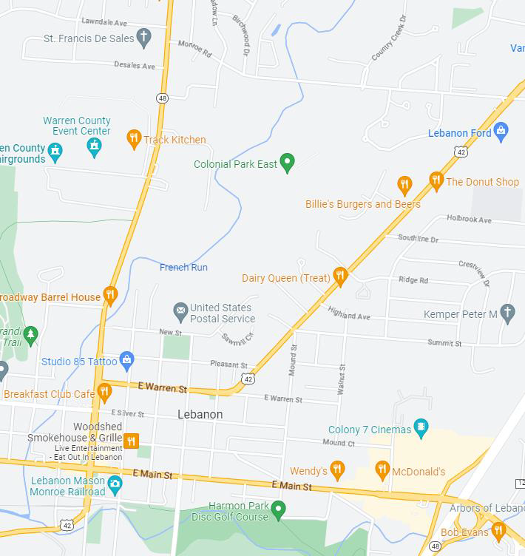

Colonial Park East Building Photos

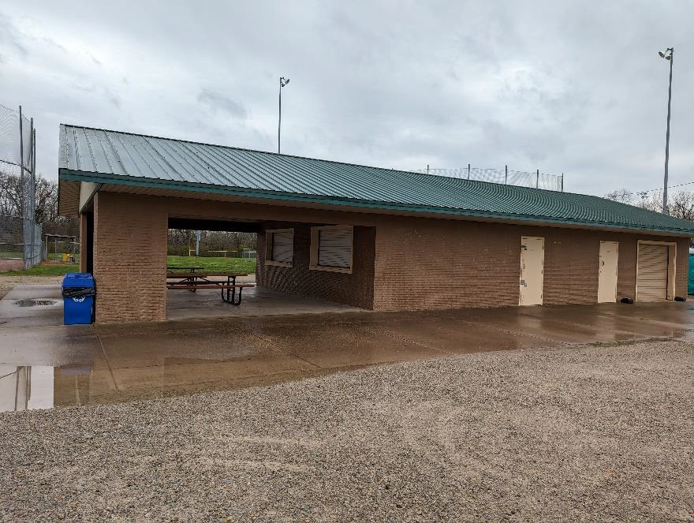

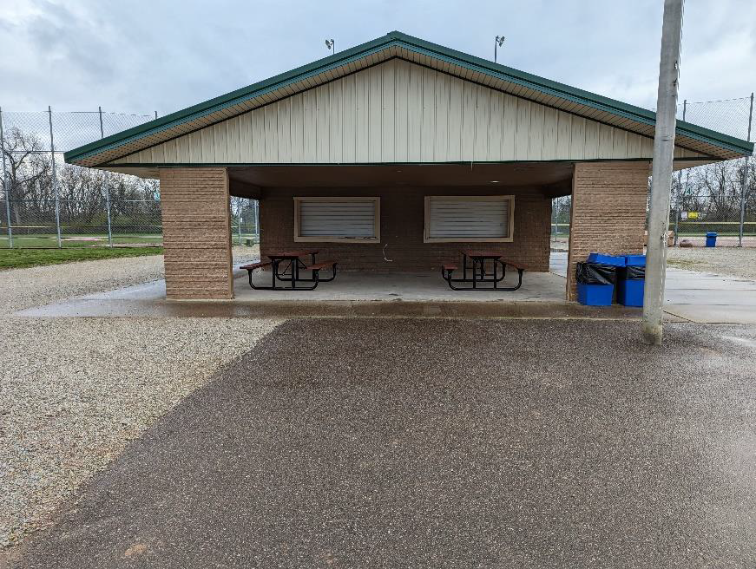

Bicentennial Park Stage Concept

